Design – Class Diagram

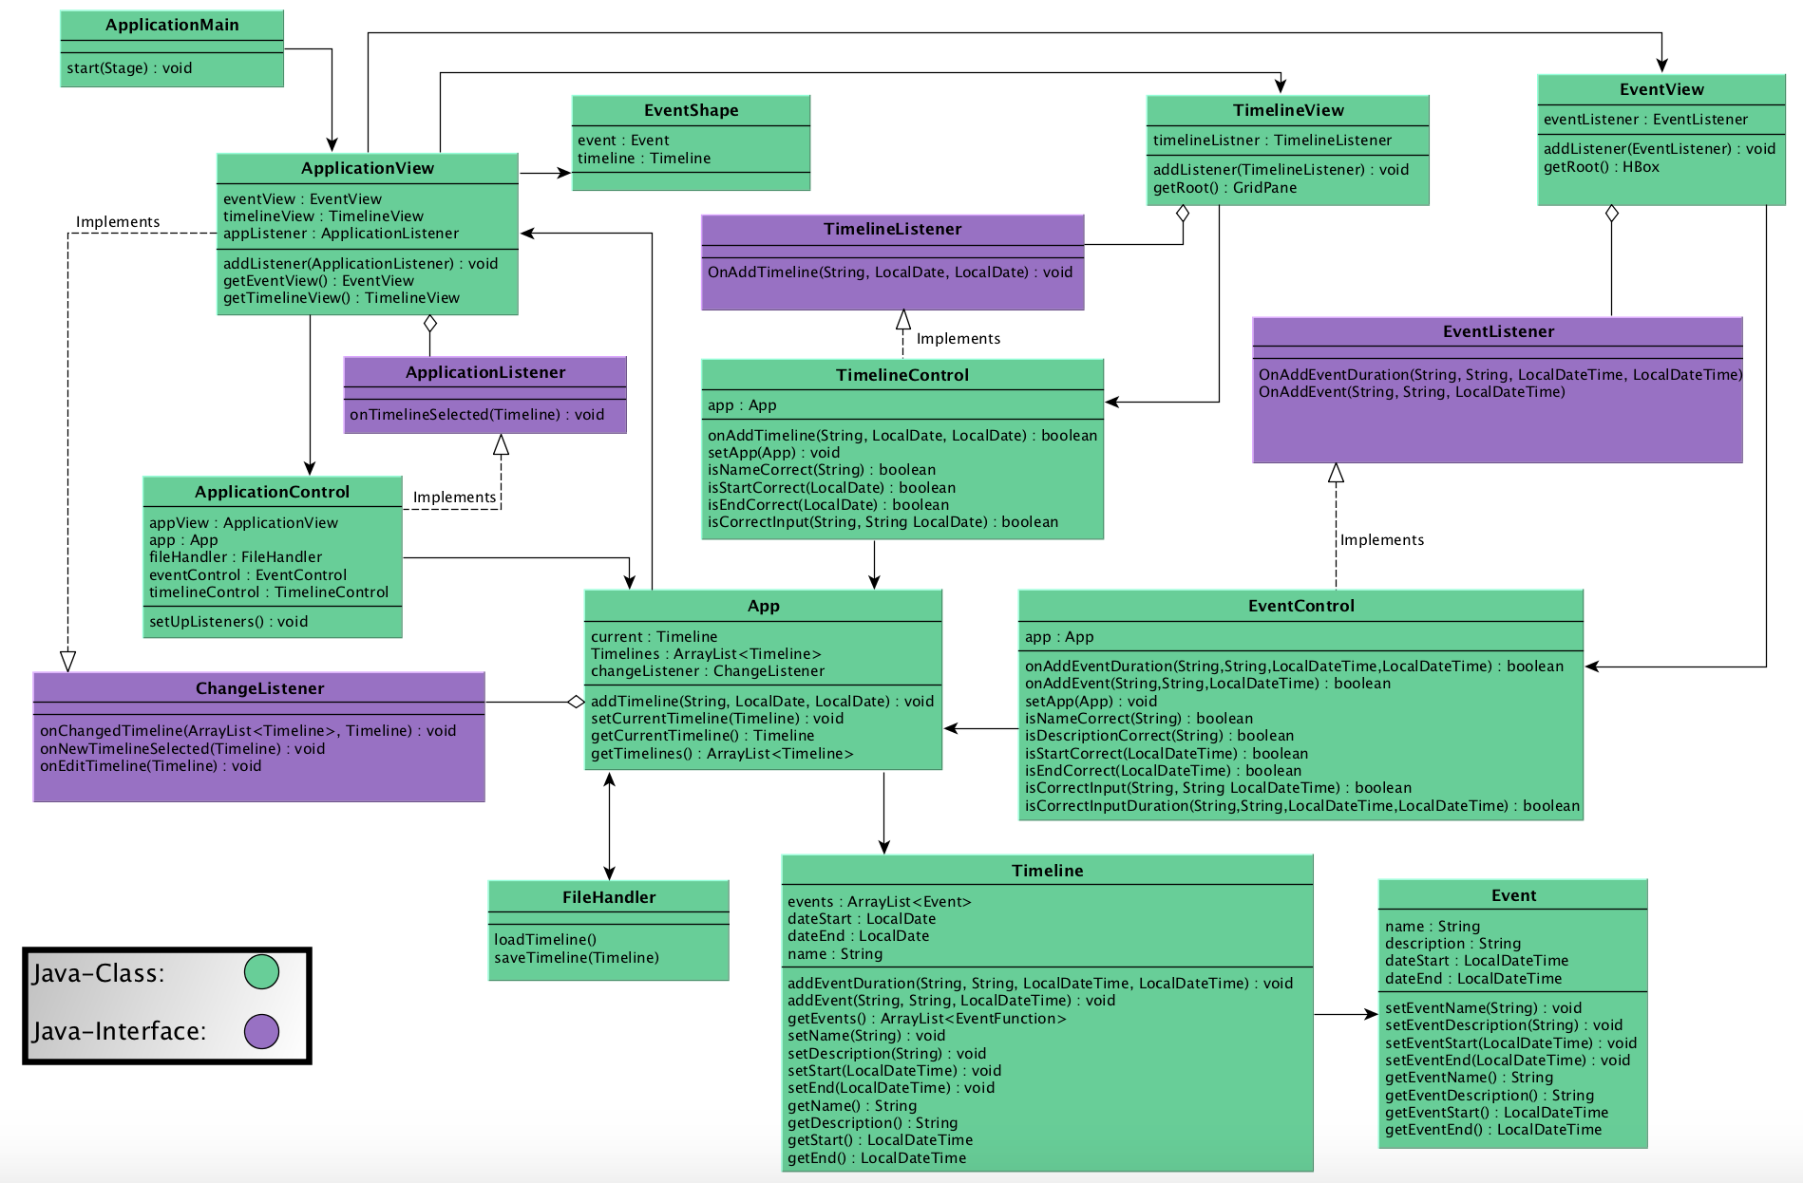

ApplicationView is the main class for creating the User Interface, it collects parts from TimelineView and EventView and puts it all together. Also the ApplicationView implements the ChangeListener (java-interface) in order to receive information from App when a Timeline or Event is created, modified or deleted. The ApplicationView also got access to the EventShape class that takes the current event and timeline as input and creates a circle along with a duration bar (if it is a duration event) with the correct position at the visual timeline. The ApplicationView also have knowledge about the ApplicationListener (java-interface) that is implemented by the ApplicationControl that updates the current timeline variable within App.

ApplicationControl is also responsible for setting up the Listeners and giving TimelineControl and EventControl access to the App.

TimelineView is the class responsible for creating buttons and popup windows associated with creating, modifying or deleting timelines. TimelineView has knowledge about the TimelineListener that is implemented by TimelineControl that is responsible for creating or deleting timelines through App.

EventView is the class responsible for creating buttons and popup windows associated with creating, modifying or deleting events. EventView has knowledge about the EventListener that is implemented by EventControl that is responsible for creating, modifying or deleting events through App.

App is the main function class and all creations of new timelines and events goes through here. It holds an ArrayList with all open timelines along with variables for the currently used timeline and event. Through the ChangeListener the App also informs the ApplicationView when there have been changes made to either the ArrayList with Timelines or the current timeline and event.

Timeline holds information about a timeline, it has an ArrayList that contains all events created within the timeline along with information about the name, start date and end date. The Timeline class also is responsible for creating the event but the method needs to be called from the App since the App is the class corresponding with TimelineView and EventView.

Event holds information about an event, it has variables for name, description, start date and end date (end date only if it is a duration event).